**Application Demo**

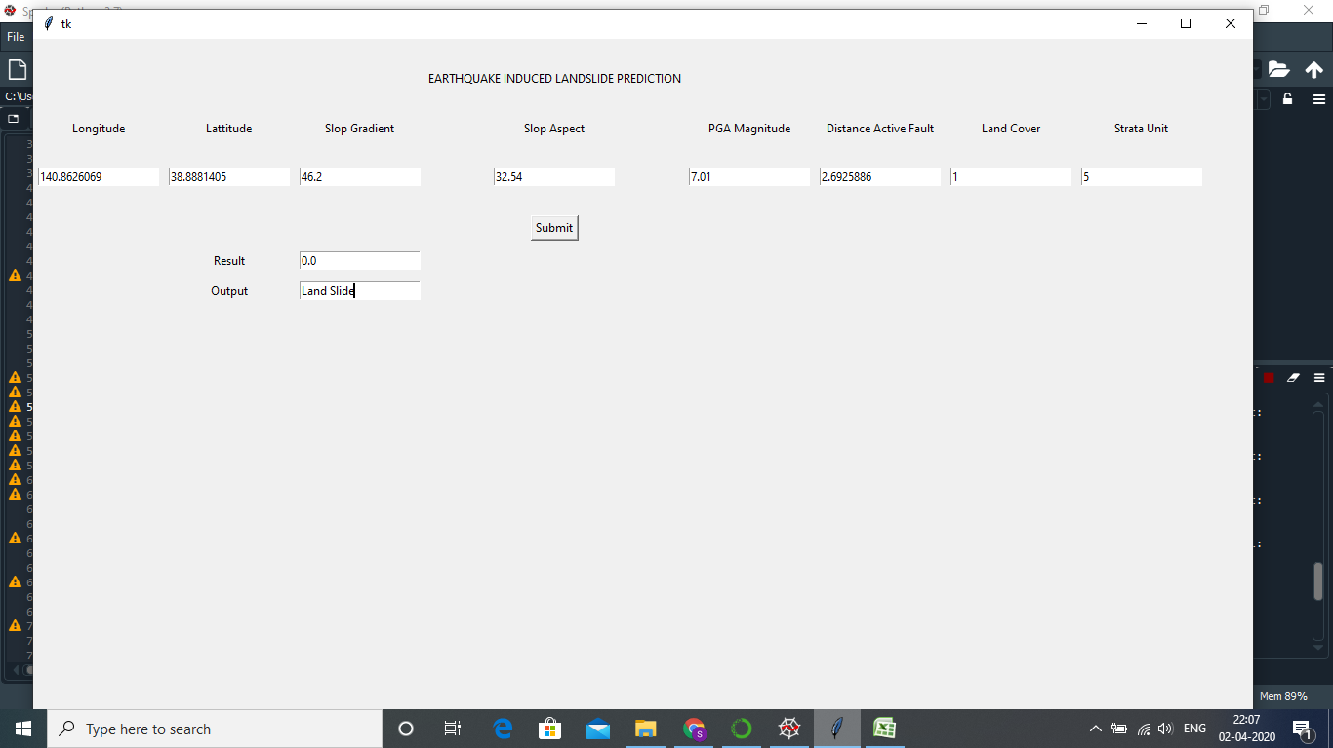

Result is Landslide or NonLandslide